**1.Below, we have represented six data points on a scale where vertical lines on scale represent unit.**



Ans : It’s a little tricky to visualize this one by just looking at the data points. We can simply substitute values to understand the mean. Let A be 1, B be 2, C be 3 and so on. The data values as shown will become {1,1,1,4,5,6} which will have mean to be 18/6 = 3 i.e. C.

**2.Which measure of central tendency suits the best for this bi-modal distribution?**

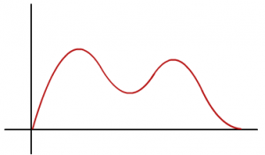

**Ans:**In Bimodal distributions, if distribution is symmetric then mean or median could be the representative for Central tendency whereas in this case due to skewness which can be clearly seen in the image, the mode lies at the left ‘bump’ and the mean lies close to the left ‘bump’ too(due to the left skew). Whereas the median should lie fairly at the centre.

**3. Which of the following is a possible value for the median of the below distribution?**

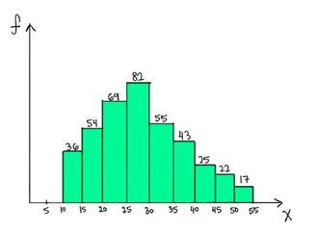

**Ans:**To answer this one we need to go to the basic definition of a median. Median is the value which has roughly half the values before it and half the values after. The number of values less than 25 are (36+54+69 = 159) and the number of values greater than 30 are (55+43+25+22+17= 162). So the median should lie somewhere between 25 and 30. Hence 26 is a possible value of the median**.**